Module 6 Project

Michael Rothbauer

Rasmussen College

Author Note

This paper is being submitted on December 13th, 2018, for Michael Rothbauer’s Advanced Mobile Web Applications.

Module 6 Project

Website link: https://sotd.us/michaelrothbauer/CIS%204655/Module%206/Project/

Repository: <https://github.com/michaelrothbauer/CIS4655C-Advanced-Web/tree/master/Module%205>

Notification permission:

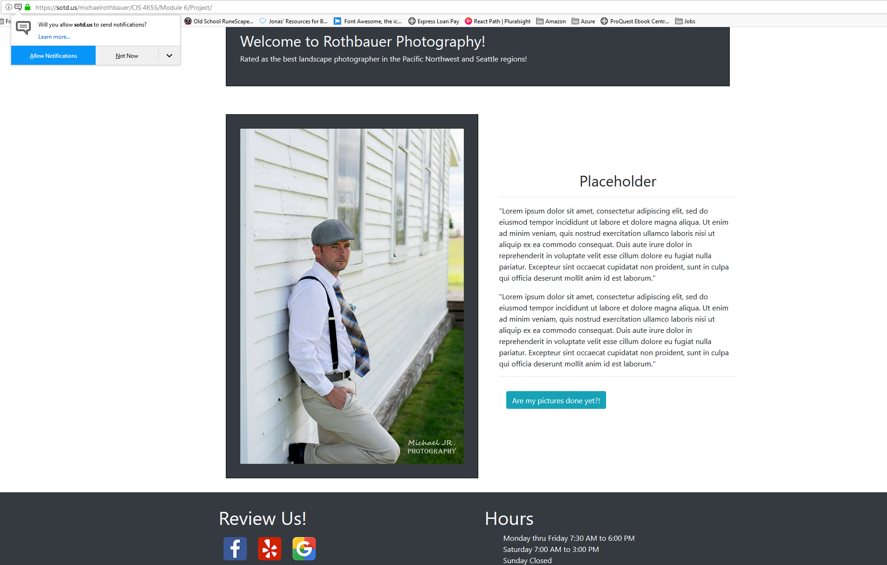

Clicking “Are my pictures done yet?!”

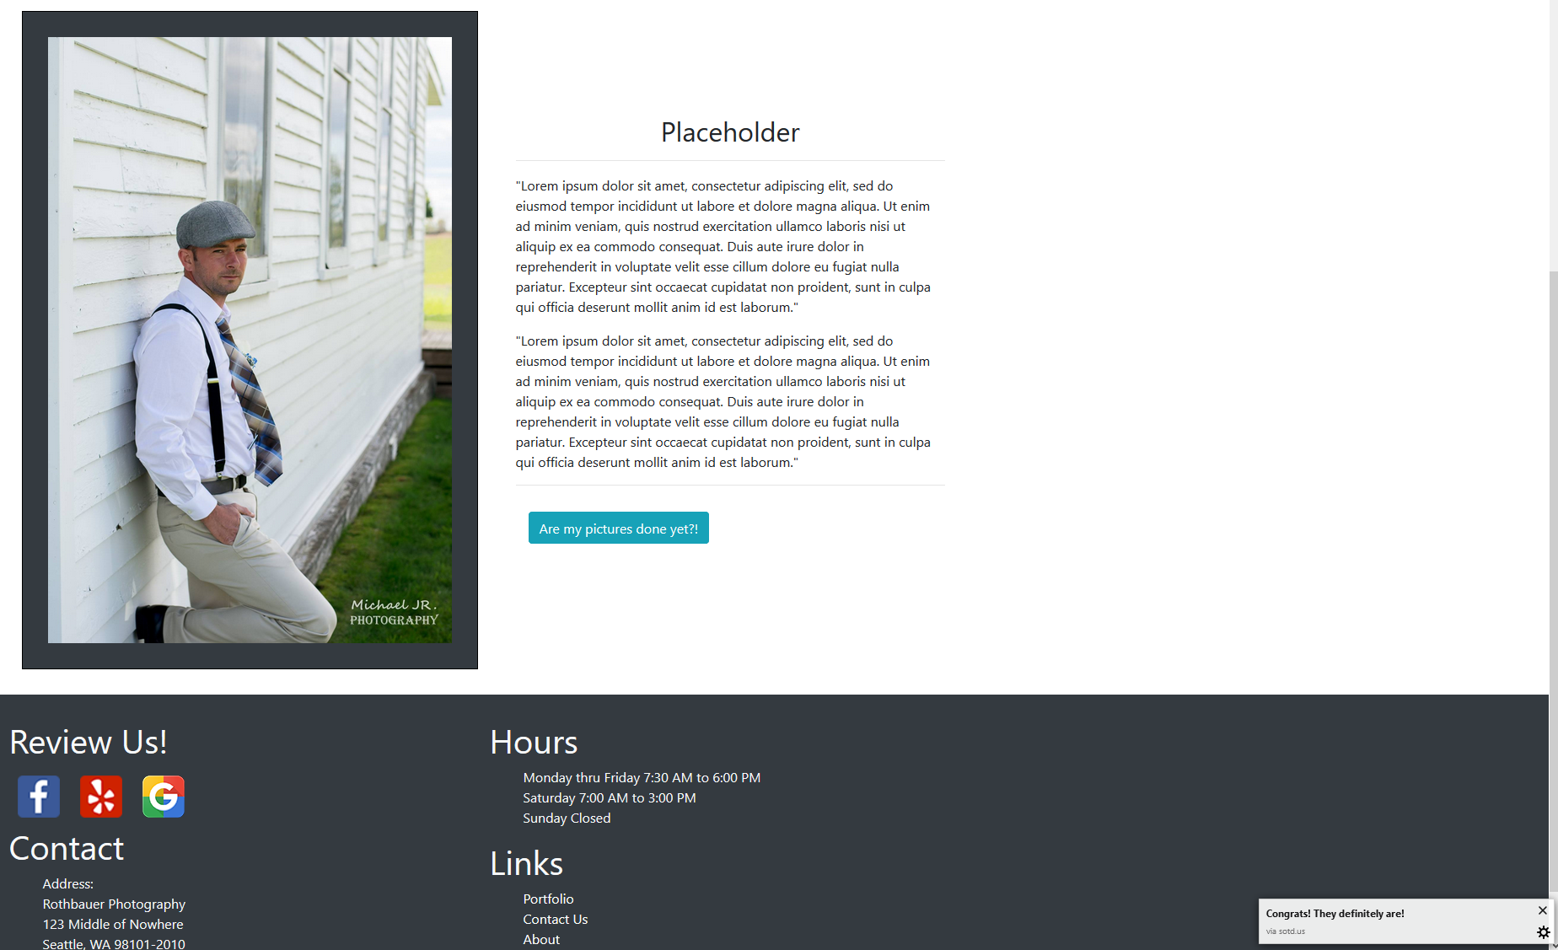

Code:

